Original Article
Characterization and antibacterial activity of melanin pigment from marine bacterium Actinoalloteichus cyanogriseus
Muddukrishnaiah Kotakonda¹, xxxxxxxxxxx^{1, *}, xxxxxxxxxxxx²
¹ICAR- Central Institute of Brackishwater Aquaculture, Chennai – 600028, India.
²Department of Chemistry, University of North Bengal, Darjeeling – 734013, India.

Abstract
Introduction: Marine microbes are known to produce novel bioactive compounds. In this work, the bacterium Actinoalloteichus cyanogriseus, AU-RM-4, isolated from marine soil sediment, capable of producing high amounts of black extracellular melanin pigment when grown on anaerobic actinomycetes agar is reported. The maximum melanin production was approximately 2.5 mg/mL. Methodology: The melanin pigment was recovered using acid treatment and the characteristic melanin absorption peaks at 253 nm and 291 nm were observed in the UV range. The antibacterial activity of the melanin pigment against a range of clinically infectious bacteria was assayed in vitro by disc diffusion and serial dilution methods. Results: The A. cyanogriseus melanin showed antimicrobial activity against Staphylococcus aureus and Klebsiella pneumoniae (MIC value -500 µg/mL). The effects of the AU-RM-4 melanin on the morphology of pathogenic bacteria was observed under scanning (SEM) and transmission electron microscopy (TEM). It is concluded that A. cyanogriseus isolate AU-RM-4 is a promising melanin-producing marine bacterium, whose melanin pigment has antibacterial activity against certain pathogenic bacteria (S. aureus and K. pneumoniae). Conclusion: Melanin produced by A. cyanogriseus AU-RM-4 could have commercial potential in the pharmaceutical and cosmetic industries for the production of pharmaceutical formulations, and also in the food industries as a colouring and antibacterial agent.
Keywords: Marine sediment bacteria; Actinoalloteichus cyanogriseus; Melanin; UV; IR; Antibacterial activity.
- Introduction
The ability of marine bacterial populations to synthesise a wide range of bioactive compounds, such as pigment molecules, is enormous. Several marine bacteria appear to create a variety of colours on standard microbial culture media. The quorum-sensing mechanism appears to be involved in the microbial production of these pigments [1]. Several marine bacterial pigments also appear to have biological functions, showing, for example, antibacterial, anticancer, and immunosuppressive properties. Studies on natural products and microbial autecology research have recently boosted the demand for novel eco-friendly natural products, like bacterial pigments, for various biomedical and commercial processes.
The pigment molecules produced by marine bacteria include phenazines, prodiginines and melanins: phenazines are tiny nitrogen-containing heterocyclic aromatic chemicals that are tricyclic and redox-active; prodiginines are aromatic chemical compounds with a core structure of pyrrolyl dipyrromethene; while melanins are polyphenolic substances that result from the hydroxylation, oxidation, and polymerization of phenolic molecules [2]. Melanins are high molecular-weight molecules that are particularly difficult to analyse since they are photochemically stable and nearly insoluble in most organic solvents, acids, and water [3]. Dark brown eumelanin and yellow or reddish pheomelanin are the two main kinds of melanin. Most melanins appear to be indole-based polymeric compounds with varied proportions of other pre-indolic products, and the basic structural unit of melanin is usually represented by covalently attached indolic compounds [4]. In addition to being a biopolymer derived from natural sources, melanin has shown good biocompatibility and biostability in living organisms, demonstrating an absence of cytotoxicity or antigenic response side effects, as well as having a relatively long half-life due to the lack of enzymes that can degrade this class of pigments in living cells [2]. Phyllosticta capitalensis [5], Spissiomyces endophytica [6], Chroogomphus rutilus (fungi) [7] and Streptomyces bikiniensis [8] naturally synthesize melanin. Streptomycetes are well-known sources of antimicrobials and secondary metabolites, accounting for 80% of all known antibiotics, and their ability to synthesise melanin-type pigments is a significant characteristic of this genus. Melanin has a photoprotective role against radiation in organisms and cells, shielding them from UV radiation and allowing them to absorb reactive oxygen species, thereby minimising UV damage [9]. Melanins have been extensively studied in living species, primarily for their photoprotective effects, but also for potential biomedical applications. Their polymorphic features, on the other hand, make studying them a perpetual challenge. Pigment molecules derived from marine bacteria have shown cytotoxic, antioxidant, antibacterial, antimalarial, anticancer, antitumor, and antifouling characteristics, amongst others [10].
Natural pigment molecules of microbial origin are in high demand in the market because of their functional characteristics, such as nontoxicity, ease of genetic manipulation, high biomass production volume, and environmental acceptability. Exploration, exploitation, and identification of novel or rare forms of pigment compounds derived from marine-coloured bacteria are thus required for an extensive range of biological and industrial uses. Because of their functional activities, cognitive scientists and the food industry are currently looking for natural pigments derived from marine microorganisms. Compared with bacteria of terrestrial origin, these pigment compounds from marine microbes have not yet been completely investigated. Hence, this study was undertaken to isolate, identify and study the biological properties of the melanin produced by the bacteria Actinoalloteichus cyanogriseus, isolated from marine sediments.
- METHODOLOGY
  - Isolation and identification of a bacterial strain producing melanin
Marine sediments from the Gulf of Mannar (Rameswaram, India) were collected using manual sampling method. The samples were transferred to plastic containers and transported to the laboratory. Sediment samples were serially diluted twice in sterile seawater. A 1 mL sample from each dilution was spread on actinomycetes agar (Himedia, India) plates and incubated at room temperature for 20 days. The colonies producing pigments were isolated using the crowded plate method.
  - Phenotypic identification
The isolated bacterial strain, AU-RM-4 was subjected to Gram’s staining and biochemical tests for: indole, methyl red, acetoin (using the Voges-Proskauer test), citrate, glucose, adonitol, arabinose, lactose, sorbitol, mannitol, rhamnose and sucrose; using a rapid biochemical identification test kit (KB001- Himedia India). Morphological analysis of the AU-RM-4 bacterial culture was performed by field emission electron microscope (FESEM, TESCAN, Czech Republic).
  - Genotypic identification
To identify and determine the phylogenetic relationships of AU-RM-4, the bacterial 16s rRNA gene was amplified by PCR, using 16s rRNA gene universal primers, described by Edwards et al [11]. Sequencing of the purified PCR products was carried out using the commercial services of Yaazh Xenomics research laboratory (Coimbatore, India). The AU-RM-4 sequence was compared with published sequences using the BLAST program within the GenBank database [12]. The MEGA software was used for the alignment of the 16s rRNA gene sequence of the AU-RM-4 with phylogenetically related genera.
  - Melanin production and purification
AU-RM-4 bacteria were grown for five days in 20 mL test tubes containing the actinomycetes anaerobic culture media. After five days, the inoculum was added to 200 mL actinomycetes anaerobic culture media and incubated at room temperature for 20 days. Melanin was purified from the fermented broth by the method described by El-Naggar and El-Ewasy [13]. To remove cells and detritus, the fermentation broth was centrifuged for 5 minutes at 10,000g. The pH of the supernatant was adjusted to 2.0 with 1 M HCl and left to stand for 12 h to precipitate the melanin. The precipitate was then collected by centrifuging at 10,000g for 5 minutes. To extract the pure pigment, the melanin pellets were washed twice with distilled water and centrifuged at 10,000g for 5 minutes.
  - Spectroscopic analysis of purified bacterial melanin
    - UV-Spectroscopy
The purified melanin was dissolved in 0.5 M NaOH solution before being scanned in a UV-visible spectrophotometer from 200 to 900 nm with 0.5 M NaOH solution as the blank.
    - FT-IR (Fourier transform infra-red spectroscopy)
The most useful application of FT-IR is for detecting functional groups and interpreting the structure of unknown substances. The melanin powder and KBr powder were mixed and prepared into a mixed-KBr pellet. An FTIR spectrophotometer was used to scan the mixed pellet at 4000–400 cm⁻¹ (Shimadzu FTIR-8400 S).
  - Antibacterial Activity of Melanin
    - Culture Media and Clinical Microorganisms
To examine the antimicrobial activity of the purified bacterial melanin, it was tested against a selection of clinically important microorganisms. The clinical microbial cultures, viz. Staphylococcus aureus, Streptococcus pyogenes, proteus mirabilis, Escherichia coli, Enterococcus faecalis, Klebsiella pneumoniae and Pseudomonas aeruginosa, were procured from the Clinical Microbiology Lab, Coimbatore, India. The clinical microorganisms were subcultured independently in 5 mL of sterile nutrient broth for 24 h at 37°C and adjusted to match the turbidity of a MacFarland standard.
    - Disc preparation
A stock solution of melanin was prepared by dissolving 1.0 g in 500 µL DMSO solvent; from this stock solution, 100 µL was added to each Himedia sterile disc under aseptic conditions. Discs were air-dried completely under aseptic conditions. The dried melanin discs were used to assess the antibacterial activity of melanin, and DMSO solvent dried discs were used as controls.
    - Kirby-Bauer Method (disc-diffusion method)
The antibacterial activity of the purified melanin was studied using the disc-diffusion method against S. aureus, S. pyogenes, P. mirabilis, E. coli, E. faecalis, K. pneumoniae and P. aeruginosa. Fresh agar plates were prepared using MHA double strength medium (7.6 g in 100 mL) (Himedia), previously autoclaved at 121°C for 15 minutes. The clinical microbial cultures were seeded on the surfaces of the MHA plates using sterilized cotton swabs. Melanin discs were prepared as described above and placed aseptically on the bacterial culture-coated agar plates. DMSO solvent discs were used as negative controls, and 5 µg ciprofloxacin was used as standard. Subsequently, the plates were incubated at 37°C for 24 h. Antibacterial activity was evaluated by using the zone reader (Himedia).
    - Determination of minimal inhibitory concentration (MIC) for bacterial melanin
The method of micro-dilution used to establish the antibacterial potential of the melanin and respective controls was as follows. Each bacterial culture was grown to a spectrophotometer reading of 0.22 optical density at 595 nm (OD595= 0.22), equivalent to 10⁸ CFU/mL. Different concentrations of melanin (500, 250, 125, 62.5, 31.25, 15.525 µg/mL) in DMSO, plus DMSO alone and ciprofloxacin, as negative and positive controls, respectively, were added to 24-well culture plates. 100 μL of the 10⁸ CFU/mL bacterial cultures were added to each well. The 24-well plates were incubated overnight at 37°C for 24 h. The 2,3,5-triphenyl-tetrazolium salt (TTC) staining assay was carried out as described by Moussa et al. (2013) [14], with modifications. Briefly, a 1% solution of 2,3,5-triphenyl-tetrazolium salt was made by dissolving it in sterile water. 100 µL of 1% TTC was applied to the treated and untreated bacterial cells on the 24-well plates. Plates were incubated at 37°C for 20 minutes in the dark. Color changes were noticed after incubation.
  - Effect of melanin on clinical Staphylococcus aureus and Klebsiella pneumoniae
To examine the phenotypic effects of melanin treatment upon the clinically important bacteria they were examined by scanning and transmission electron microscopy. The Staphylococcus aureus and Klebsiella pneumoniae bacteria that had been treated with melanin at 500 µg (MIC concentration; 37°C, 12 h) were subsequently centrifuged, washed twice, and resuspended in PBS. The cells were fixed for 2 h at room temperature in 2.5% glutaraldehyde, dehydrated with alcohol, dried with hexamethyldisilazane (HMDS), and then coated with gold. SEM was used to investigate the interactions of the melanin with the bacterial cells (FESEM, TESCAN). From harvest to centrifugation, the sample preparation for transmission electron microscopy (TEM) was the same as SEM. A drop of the suspension was deposited on a copper grid and dried. Grids were run at 200 kV using a JEM-2100PLUS TEM (JEOL Ltd., Japan).
- RESULTS AND DISCUSSION
  - Isolation of pigment producing Actinoalloteichus cyanogriseus from marine sediment.
The ash-coloured, sporulating, slow-growing colony, showing black diffusible pigment on the actinomycete isolation agar (Fig. 1.) under facultative anaerobic conditions, was picked and isolated using the streaked plate method. The isolate was named AU-RM-4. Although A. cyanogriseus is reported to be aerobic (Tamura et al., 2000) [15], the strain isolated could grow under microaerophilic conditions.
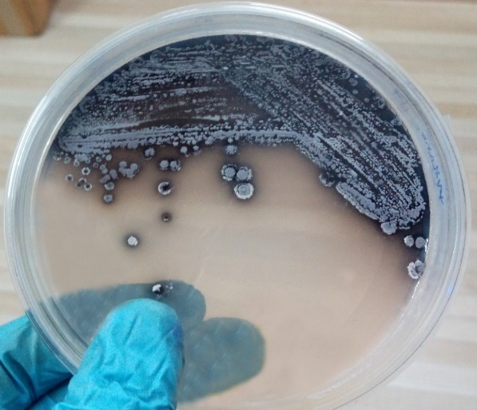
Fig. 1. Actinoalloteichus cyanogriseus AU-RM-4 produces a black pigment on agar plate
  - Morphology and culture characteristics of the strain AU-RM-4
Examination of the morphological and cultural characteristics of AU-RM-4 revealed it to be gram-positive, exhibiting extracellular pigment secretion with facultative anaerobic growth. The bacterial cell morphology was also observed using a scanning electron microscope (Fig. 2.). The bacteria produced branching spore chains. The biochemical characteristics of strain AU-RM-4 are summarised in Table 1. The optimal growth temperature of AU-RM-4 was found to be 27°C and optimal growth pH was 7.0. Carbon utilization analysis showed that citrate, D-glucose, sucrose and rhamnose are utilized as sole carbon sources.
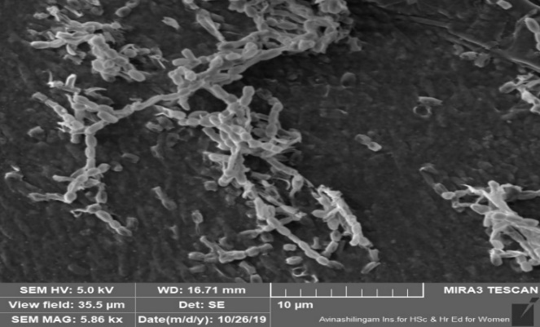
Fig. 2. Scanning electron microscope image of AU-RM-4 showing the distinctive long spore chain morphology.
Table 1. Phenotypic characteristics of AU-RM-4
S.NO | Test | Results
1 | Indole test | -
2 | Methyl red | -
3 | Voges-Proskauer | -
4 | Citrate | +
5 | Glucose test | +
6 | Adonitol test | -
7 | Arabinose test | -
8 | Lactose test | -
9 | Sorbitol test | -
10 | Mannitol test | -
11 | Rhamnose | +
12 | Sucrose test | +

  - Molecular identification of the AU-RM-4 by genomic analysis (16s rRNA)
PCR amplification of AU-RM-4 16s rRNA yielded a 1250 bp product. The PCR product was sequenced and the sequence was used to perform a BLAST search on the NCBI GenBank database. The 16S rRNA gene sequence of strain AU-RM-4 showed maximum similarity to those of streptomyces species, sharing 99.84–100% gene (16S rRNA) sequence similarity. A phylogenetic tree was created using the MEGA X program [16]. This tree demonstrates the evolutionary relationship of strain AU-RM-4 to several different streptomyces species. Phylogenetic evaluation confirmed that the strain AU-RM-4 shows 99.84% similarity with A. cyanogriseus strain SIR5 (NCBI accession No. MK793584.1), and 100% similarity with A. cyanogriseus strain ZZ1886, 12A22 (NCBI accession No. MT096343.1, MK346266.1) (Fig. 3).
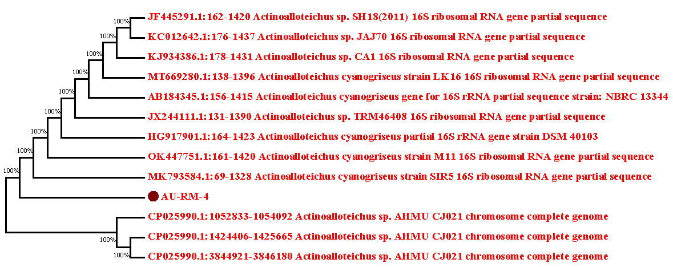
Fig. 3. The taxonomic relationship between strain AU-RM-4 and other Actinoalloteichus cyanogriseus strains, as shown by the phylogenetic tree based on 16S rRNA gene sequences.
3.4. Pigment production by A. cyanogriseus
A. cyanogriseus produced black pigment in actinomycetes agar and broth after 10 days of incubation (Fig. 4). Saratha et al., [17] isolated A. cyanogriseus from mulberry rhizosphere producing melanin which exhibited anti-fungal activity against mulberry root rot pathogens viz., Macrophomina phaseolina, Lasiodiplodia theobromae, Fusarium solani, Sclerotium rolfsii and Rhizoctonia solani. Eumelanin is produced by the oxidation of L-tyrosine to 3,4-dihydroxyphenylalanine and to dopaquinone by tyrosinase which in turn is converted to eumelanin (Soliev et al., 2011) [18].
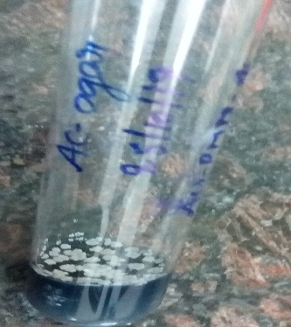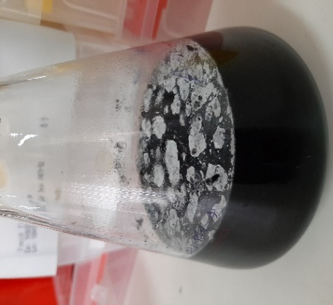
Fig. 4. Actinoalloteichus cyanogriseus AU-RM-4 produces a black pigment on anaerobic actinomycetes agar (left panel). The right panel shows a 10-day anaerobic culture of A. cyanogriseus AU-RM-4 in actinomycetes broth.
3.5. Fermentation and Pigment isolation
To obtain bacterial pigment for analysis, the AU-RM-4 bacterial culture was fermented in anaerobic actinomycetes media for twenty days. On the tenth day, extracellular secretion of black pigment was observed (Fig. 5.). The fermented AU-RM-4 culture was then centrifuged to separate bacterial cells from the extracellular secreted compounds.
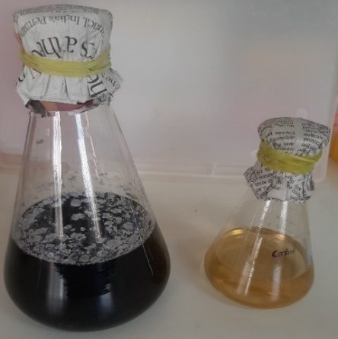
Fig. 5. Black pigment production by Actinoalloteichus cyanogriseus strain AU-RM-4. The left flask contains a 20-day culture of AU-RM-4 grown in anaerobic actinomycetes media, showing melanin secretion. The right flask contains sterile anaerobic actinomycetes media.
3.6. Melanin isolation
The black pigment produced from A. cyanogriseus strain AU-RM-4 was extracted from the culture medium, as described in the methods section (Fig. 6.). The yield of pigment obtained from AU-RM-4 grown in 200 mL of anaerobic actinomycetes broth was 500 mg. The melanin yield reported from other species are, Spissiomyces endophytic 315.20±13.57 mg/g dried fungal biomass [6], S. bikiniensis 166 mg/L [8] and Yarrowia lipolytica (0.5 mg/ml) [19].
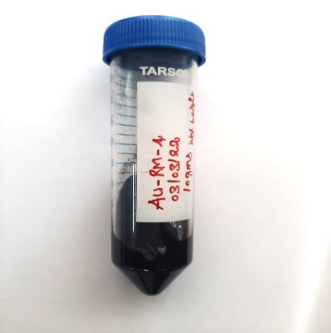
Fig. 6. Purified black pigment from A. cyanogriseus strain AU-RM-4.
3.7. UV–visible spectrophotometric examination
The UV-visible absorbance range of the purified pigment was 200 – 800 nm, which corresponds to that known for melanin. The melanin purified from A.cyanogriseus and commercial melanin (Merck) showed similar absorbance spectra (Fig 7). The absorbance at 250 nm was similar to the absorption peak of Streptomyces sp. NEAE-H melanin pigment [12]. Purified Actinoalloteichus sp MA-32 strain melanin exhibited a maximum UV-Vis absorption peak of 300 nm [20], whereas melanin synthesised by Streptomyces bikiniensis M8 exhibited an absorbance at 230 nm [8]. The purity of AU-RM-4 (Actinoalloteichus cyanogriseus) melanin was confirmed by UV visible spectroscopy and we found no peaks indicative of impurities, such as nucleic acids or proteins.
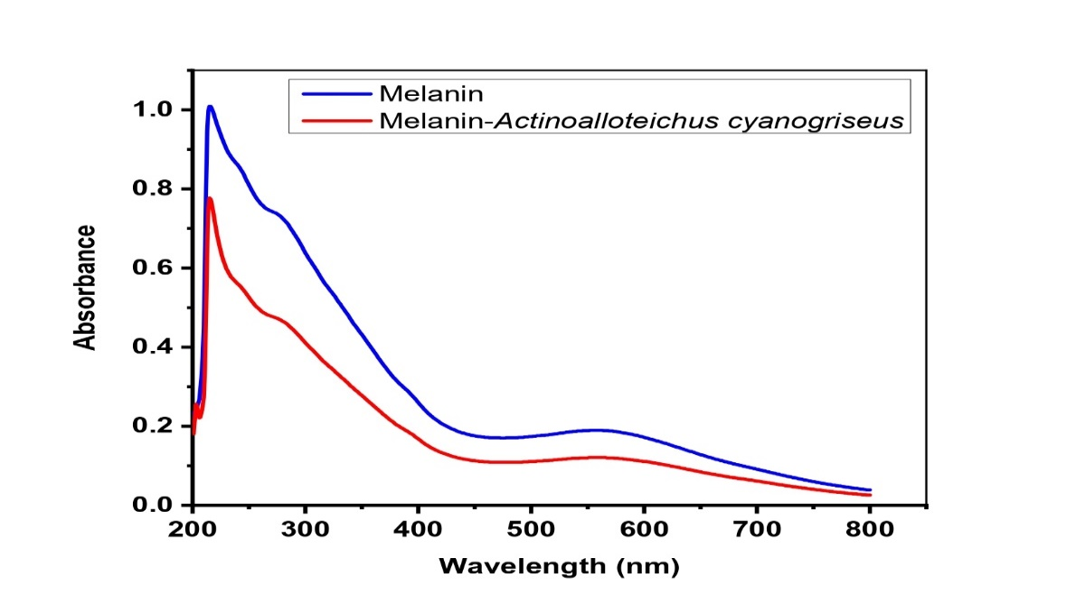
Fig. 7. UV-visible absorbance spectrum (200 – 800 nm) of the purified melanin pigment of Actinoalloteichus cyanogriseus strain compared with that of commercially available melanin.
3.8. Melanin FTIR analysis
Analysing the FTIR spectrum is one of the most frequently used spectroscopic techniques for identification of various biomolecules. The FT-IR spectrum of purified melanin exhibits absorbance at 3200-2700 cm⁻¹ (3059.20 cm⁻¹, 2947.33 cm⁻¹), which indicates the N-H and O-H stretching vibrations in the presence of phenolic, amine, amide, and carboxylic acid functional groups present in the indole and pyrrolic system [21]. The peak observed between 1650-1580 cm⁻¹ (1619.29 cm⁻¹) indicates the presence of amine N-H bending and specifies that pigment indole structure of melanin. The peak between 1400 and 1500 cm⁻¹ (1456.30 cm⁻¹⁾ indicates the C-H aliphatic group in melanin pigment [22]. The peak at 1250-1310 cm⁻¹ indicates the (C-O) anhydride group in melanin and in all purified microbial pigments [23]. The peak at 1077.28 cm⁻¹ is the sign of aliphatic C-H in the melanin pigment. The peak observed at 900-700 cm⁻¹ (845.81 cm⁻¹) indicates a C-H aromatic group. The pigment obtained from A. cyanogriseus exhibited spectroscopic properties consistent with those of melanin produced by other bacteria, as previously described [23]. Therefore, on the basis of the FT-IR spectroscopic results, the pigment was confirmed to be eumelanin (Fig 8).
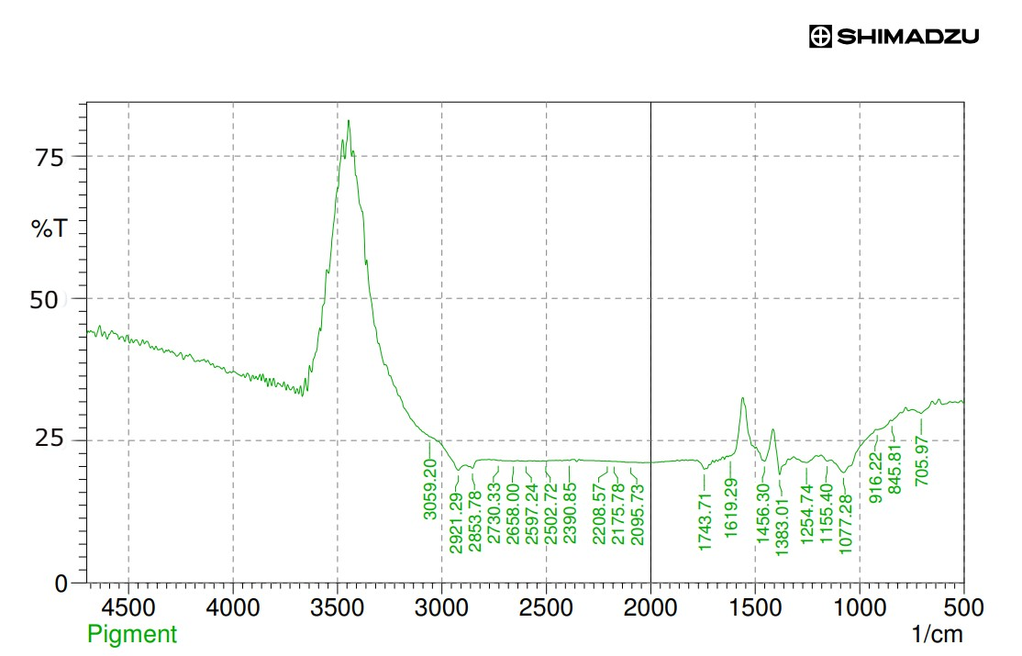
Fig. 8. FT-IR spectroscopic analysis of the melanin produced by Actinoalloteichus cyanogriseus strain AU-RM-4 pigment shows it to be eumelanin.
3.9. Antimicrobial activity
The microbial activity of the AU-RM-4 pigment against clinically important microorganisms was evaluated using the disc diffusion method (100 µL/disc of crude pigment) on plates bearing a lawn of the appropriate clinical microorganism. The diameters of the resulting zones of inhibition were measured, and the results are shown in Table 2 and in Fig 9, where it can clearly be seen that the AU-RM-4 pigment inhibits growth of Staphylococcus aureus and Klebsiella pneumoniae, producing inhibition zones with diameters 16 mm and 19 mm, respectively. However, it has no effect on the other pathogens tested. This contrasts with the results obtained by Setiyono and colleagues [10], using pigments from the marine bacteria Pseudoalteromonas rubra (cycloprodigiosin and prodigiosin), which exhibited antimicrobial activity against E. coli (cycloprodigiosin - 9.0 mm and prodigiosin - 10.5 mm) and S. aureus (cycloprodigiosin - 10.1 mm and prodigiosin - 25.1 nm), respectively.
Table 2. Comparison of the antimicrobial activity of AU-RM-4 pigment and standard drug against clinically important pathogens: Staphylococcus aureus, Streptococcus pyogenes, Proteus mirabilis, E. coli, Enterococcus faecalis, Klebsiella pneumoniae and Pseudomonas aeruginosa
S.NO | Microorganism | Zone of Inhibition (mm) (n=2)
S.NO | Microorganism | AU-RM-4 - Pigment | Standard  (Ciprofloxacin-5µg)
1 | Staphylococcus aureus | 16 | 22
2 | Streptococcus pyogenes | - | 20
3 | Proteus mirabilis | - | 14
4 | Escherichia coli | - | 27
5 | Enterococcus faecalis | - | R
6 | Klebsiella pneumoniae | 19 | 24
7 | Pseudomonas aeruginosa | - | 34

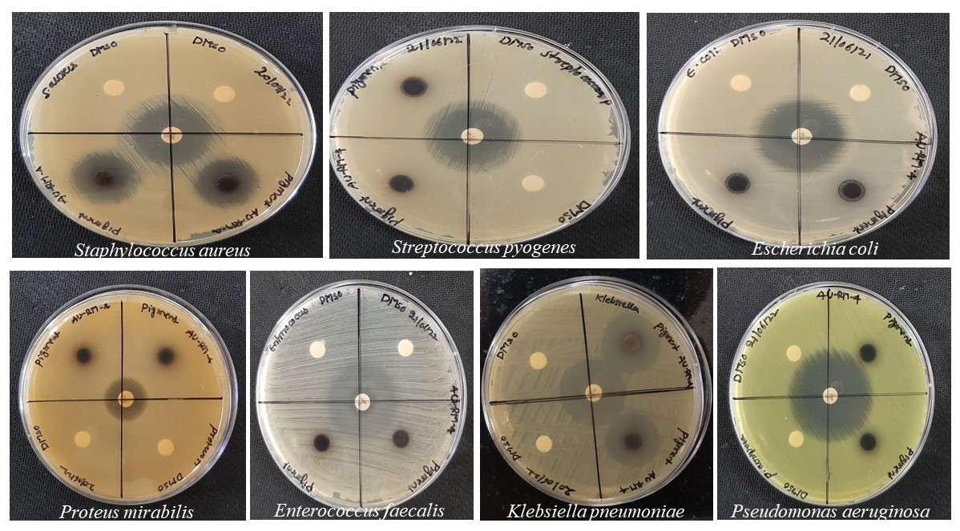
Fig. 9. Comparison of the antimicrobial activity of AU-RM-4 pigment with that of standard drugs against clinical Staphylococcus aureus, Streptococcus pyogenes, Proteus mirabilis, E. coli, Enterococcus faecalis, Klebsiella pneumoniae and Pseudomonas aeruginosa.
3.10. Determination of the MIC (minimal inhibitory concentration) for AU-RM-4 pigment extract against clinical pathogens, using the serial dilution method - Tetrazolium stain (TTC)
The antibacterial activity of purified AU-RM-4 melanin against a range of clinically important microorganisms was assayed by serial dilution. Fig 10 shows the antibacterial activity, which increases with increased concentration compared with the control. Melanin antibacterial activity (MIC value -500 µg/mL) was observed against three species of clinically important bacteria: Staphylococcus aureus and Klebsiella pneumoniae. Using tetrazolium stain (TTC), clear inhibition of the bacterial cell growth was observed: TTC stained the live bacterial cells red and the inhibited bacterial cells were colourless. Interestingly, Xu and his colleagues previously reported that another bacterial melanin, Lachnum YM30 bacterial melanin, shows antibacterial activity against V. parahaemolyticus, S. aureus, E. coli, and B. megaterium (MIC value 0.2 to 2.4 mg/mL) respectively [21]. Thus, the antibacterial activity of AU-RM-4 melanin shows overlapping, but not identical, specificity with that of YM30, suggesting that their biochemical modes of action may differ.
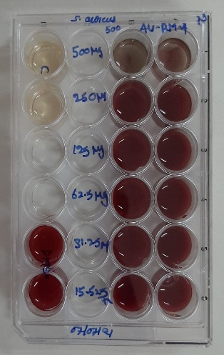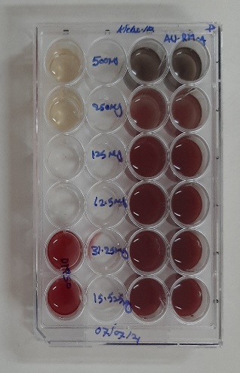
Fig. 10. Purified AU-RM-4 pigment shows antibacterial activity against clinical pathogens Staphylococcus aureus and Klebsiella pneumoniae, as shown by TTC test.
3.11. Morphological changes observed by scanning and transmission electronic microscopy (SEM and TEM)
Since previous work [24], has shown that bacterial melanin pigment can damage the integrity of the bacterial cell membrane, it was possible that AU-RM-4 melanin might also have a similar effect. To examine what effects the AU-RM-4 treatment might have on the cell surfaces of Staphylococcus aureus and Klebsiella pneumoniae, the morphological characteristics of the pathogens were observed using SEM (Fig. 11) and TEM (Fig. 12). It can clearly be seen by SEM (Fig. 11A and 11B) and by TEM (Fig. 12A and 12B) that untreated samples of Staphylococcus aureus and Klebsiella pneumoniae show regular bacterial cell morphology, with relatively smooth surfaces. In contrast, SEM (Fig. 11D and 11E) and TEM (Fig. 12D and 12E) images of samples treated with AU-RM-4 melanin pigment show rough cell surfaces and abnormal morphology.
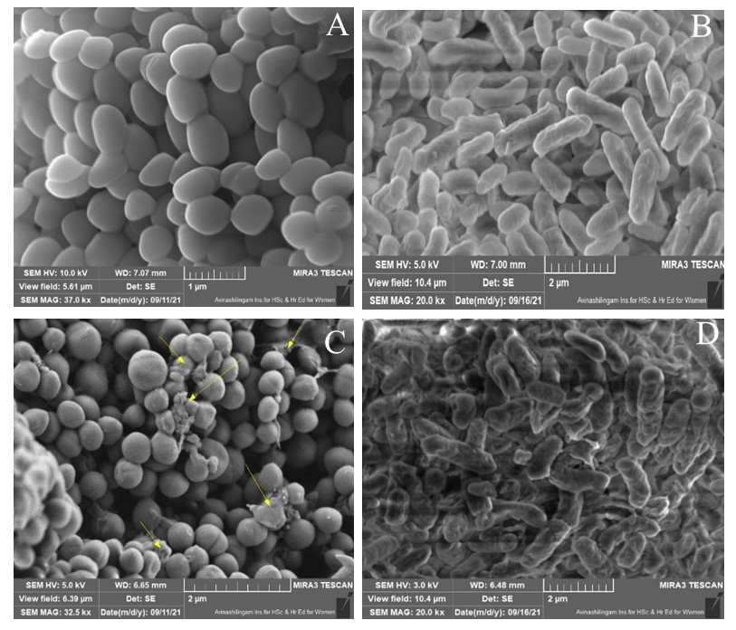
Fig. 11. Scanning electronic microscope (SEM) images: 11A and 11B: untreated Staphylococcus aureus and Klebsiella pneumoniae 11C and 11D: AU-RM-4 pigment-treated Staphylococcus aureus and Klebsiella pneumoniae.
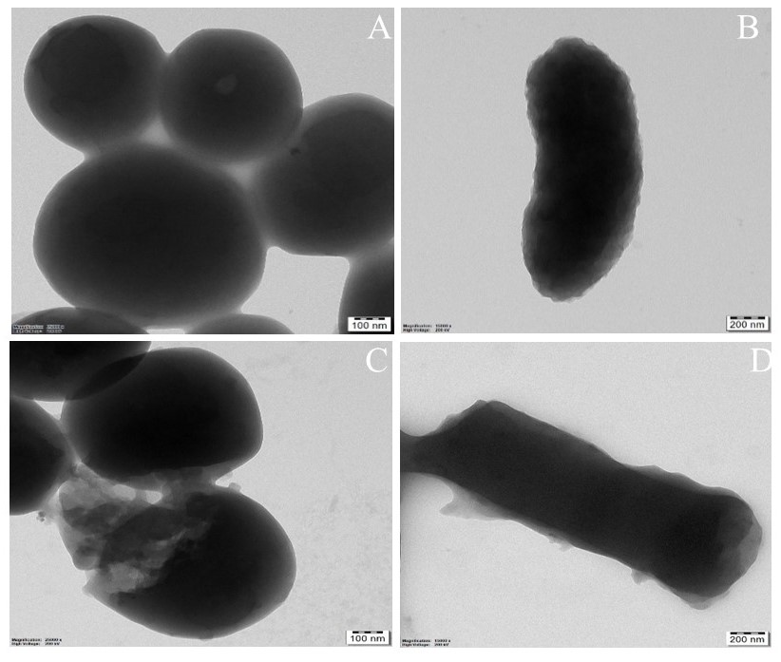
Fig. 12. Transmission electronic microscope (TEM) images: 12A and 12B: untreated Staphylococcus aureus and Klebsiella pneumoniae 12C and 12D: AU-RM-4 pigment-treated Staphylococcus aureus and Klebsiella pneumoniae.
The bacterial cell membrane is an important structural component. When the cell membrane is destroyed, the contents of the cell, such as nucleic acids, proteins, and other substances, leak out. As a result, intracellular material leakage is an essential measure of cell membrane integrity. According to Xu et al. (2017) [24], bacterial melanin pigment can affect the membrane integrity, resulting in the leakage of nucleic acids and proteins through the malfunctioning membrane. The results of SEM and TEM analysis suggest that AU-RM-4 melanin also causes loss of membrane integrity.
- Conclusion
Actinoalloteichus cyanogriseus strain AU-RM-4, a melanin producer, was isolated from a marine sediment sample collected in Rameswaram, Tamil Nadu, India. This purified melanin had the same physical and chemical properties as natural melanin. A simple culture process yielded 2.5 mg of melanin per mL culture medium, showing that A. cyanogriseus strain AU-RM-4 is a promising melanin source. We showed that AU-RM-4 melanin pigment has antibacterial activity against certain pathogenic bacteria (Staphylococcus aureus and Klebsiella pneumoniae). In addition, the melanin produced by A. cyanogriseus AU-RM-4 could potentially be used commercially in biotechnological applications in the pharmaceutical and cosmetic industries, as a colouring and antibacterial agent in topical preparations such as ointments (skin ointments) and lotions. Moreover, the isolation of melanin from Actinoalloteichus cyanogriseus is cost-effective and straightforward, resulting in a pure product.
Abbreviations:
TEM: Transmission electronic microscope
SEM: Scanning electronic microscope
Ethics Approval and Consent to Participate
Not applicable.
Human and Animal Rights
No animals/humans were used for studies that are the basis of this research.
Consent for Publication
Not applicable.
Conflict of Interest
None.
Acknowledgement
The authors would like to thank the Director of the ICAR-Central Institute of Brackishwater Aquaculture, Chennai, Tamil Nadu, India for providing the research facility and ICMR India for providing a research fellowship to Muddukrishnaiah Kotakonda.
Funding
This research was funded by the ICMR (Indian Council of Medical Research), Government of India under the Senior Research Fellowship scheme [File No. AMR/fellowship/3/2019/ ECD-II].
Contributors:
References
[1] Mohammadi, M.; Burbank, L.; Roper, M.C. Biological role of pigment production for the bacterial phytopathogen Pantoea stewartii subsp. stewartii. Appl Environ Microbiol. 2012, 78(19), 6859-6865.
[2] Solano, F. Melanin and Melanin-Related Polymers as Materials with Biomedical and Biotechnological Applications-Cuttlefish Ink and Mussel Foot Proteins as Inspired Biomolecules. Int J Mol Sci. 2017, 18(7), 1561.
[3] Tarangini, K.; Mishra, S. Production of melanin by soil microbial isolate on fruit waste extract: two step optimization of key parameters. Biotechnol Rep (Amst). 2014, 4, 139-146.
[4] Tran-Ly, A.N,; Reyes, C,; Schwarze, F.W.M.R,; Ribera, J. Microbial production of melanin and its various applications. World J Microbiol Biotechnol. 2020, 36(170), 1-9.
[5] Suryanarayanan, T.S,; Ravishankar, J.P,; Venkatesan, G,; Murali, T.S. Characterization of the melanin pigment of a cosmopolitan fungal endophyte. Mycol Res. 2004, 108 (8), 974-8.
[6] Suwannarach, N,; Kumla, J,; Watanabe, B,; Matsui, K,; Lumyong, S. Characterization of melanin and optimal conditions for pigment production by an endophytic fungus, Spissiomyces endophytica SDBR-CMU319. PLoS One. 2019,14(9), e0222187.
[7] Hu, W.L,; Dai, D.H,; Huang, G.R,; hang, Z.D. Isolation and characterization of extracellular melanin produced by Chroogomphus rutilus D447. American J Food Technol. 2015, 10 (2), 68–77.
[8] Deepthi, A,; Rosamma, P. Actinomycete isolates from Arabian Sea and Bay of Bengal: biochemical, molecular and functional characterization: Thesis, Cochin University of Science and Technology, Cochin, Kerala 682022, India. 2014.
[9] Ruan, L,; Yu, Z,; Fang, B,; He, W,; Wang, Y,; Shen, P. Melanin pigment formation and increased UV resistance in Bacillus thuringiensis following high temperature induction. Syst Appl Microbiol. 2004, 27(3), 286-9.
[10] Setiyono, E,; Adhiwibawa, M.A.S,; Indrawati. R,; Prihastyanti, M.N.U,; Shioi, Y, Brotosudarmo, T.H.P. An Indonesian Marine Bacterium, Pseudoalteromonas rubra, Produces Antimicrobial Prodiginine Pigments. ACS Omega. 2020, 5(9), 4626-4635.
[11] Edwards, U,; Rogall, T,; Blöcker, H,; Emde, M; Böttger, E.C. Isolation and direct complete nucleotide determination of entire genes. Characterization of a gene coding for 16S ribosomal RNA. Nucleic Acids Res. 1989, 17(19), 7843-7853.
[12] Zhang, Z,; Schwartz, S,; Wagner, L,; Miller, W. A greedy algorithm for aligning DNA sequences. J Comput Biol. 2000, 7(1-2), 203-214.
[13] El-Naggar, N.E,; El-Ewasy, S.M. Bioproduction, characterization, anticancer and antioxidant activities of extracellular melanin pigment produced by newly isolated microbial cell factories Streptomyces glaucescens NEAE-H. Sci Rep. 2017, 7, 42129.
[14] Moussa, S.H,; Tayel, A.A,; Al-Hassan, A.A,; Farouk; A. Tetrazolium/Formazan Test as an Efficient Method to Determine Fungal Chitosan Antimicrobial Activity. J. Mycol. 2013, 2013, 1-7.
[15] Tamura, T,; Zhiheng, L,; Yamei, Z,; Hatano, K. Actinoalloteichus cyanogriseus gen. nov., sp. nov. International Journal of Systematic and Evolutionary Microbiology. 2000, 50: 1435–1440.
[16] Kumar, S,; Stecher, G,; Li, M,; Knyaz, C,; Tamura, K. MEGA X: Molecular Evolutionary Genetics Analysis across Computing Platforms. Mol Biol Evol. 2018, 35(6), 1547-1549.
[17] Saratha, M,; Angappan, K,; Karthikeyan, S,; Marimuthu, S,; Chozhan, K. Actinoalloteichus cyanogriseus: a broad spectrum bio-agent against mulberry root rot pathogens. Egyptian Journal of Biological Pest Control. 2022, 32(33), 1-11.
[18] Soliev, A.B,; Hosokawa, K,; Enomoto, K. Bioactive Pigments from Marine Bacteria: Applications and Physiological Roles. Evidence-Based Complementary and Alternative Medicine. 2011, 2011, 670349.
[19] Ben, Tahar, I,; Kus-Liśkiewicz, M,; Lara, Y,; Javaux, E,; Fickers, P. Characterization of a nontoxic pyomelanin pigment produced by the yeast Yarrowia lipolytica. Biotechnol. 2020, 36(2), e2912.
[20] Manivasagan, P,; Venkatesan, J,; Senthilkumar K,; Sivakumar K,; Kim, S.K. Isolation and characterization of biologically active melanin from Actinoalloteichus sp. MA-32. Int J Biol Macromol. 2013, 58, 263-274.
[21] Coates, J. Interpretation of infrared spectra, a practical approach. Encyclopedia Anal Chem. 2000.
[22] Sajjan, S,; Kulkarni, G,; Yaligara, V,; Kyoung L,; Karegoudar TB. Purification and physiochemical characterization of melanin pigment from Klebsiella sp. GSK. J Microbiol Biotechnol. 2010, 20(11), 1513-1520.
[23] Hewedy, M, Ashour, S. Production of a melanin like pigment by Kluyveromyces marxianus and Streptomyces chibaensis. Aust J Basic Appl Sci. 2009, 3, 920–927.
[24] Xu, C,; Li, J,; Yang, L,; Shi, F,; Yang, L,; Ye, M. Antibacterial activity and a membrane damage mechanism of Lachnum YM30 melanin against Vibrio parahaemolyticus and Staphylococcus aureus. Food Control. 2017, 73, 1445-1451.

